CS 340 | Project Two
  - Grazioso Salvare Animal Rescue Dashboard
README and Dashboard Documentation
Cristian Alejandro | Southern New Hampshire University | CS 340: Client/Server Development

Project Purpose
This project provides an interactive dashboard for Grazioso Salvare to explore animal records from the Austin Animal Center database and identify potential rescue candidates. The application connects a Python CRUD module to MongoDB and presents searchable records, rescue-category filters, a breed distribution chart, and a map for selected animals.

Technologies and Files
- Python and Jupyter Notebook in the Codio environment
- MongoDB with PyMongo access through the AnimalShelter class in CRUD_Python_Module.py
- Dash and JupyterDash for the interface, pandas for tabular data, Plotly Express for breed charts, and dash-leaflet for the map
- ProjectTwoDashboard.ipynb — dashboard notebook; CRUD_Python_Module.py — MongoDB access module; Grazioso Salvare logo image — branding asset

Dashboard Features
- Rescue filters: Reset / Show All, Water Rescue, Mountain or Wilderness Rescue, and Disaster or Individual Tracking.
- Interactive animal table with sortable/filterable fields, row selection, and page navigation.
- Top 10 Animal Breeds chart updates to reflect the selected rescue filter.
- Animal Geolocation map displays a marker based on the selected record’s latitude and longitude.
- Dashboard branding and student identifier appear in the header.

Why These Tools Were Selected
MongoDB stores the Austin Animal Center records as flexible documents, and PyMongo provides a direct way for Python to retrieve matching animals. The reusable AnimalShelter CRUD class keeps database access separate from the dashboard interface, so filtering does not require duplicating connection code.
JupyterLab in Codio provides a convenient environment to run and demonstrate the project. Dash/JupyterDash supports the radio buttons, table, and callback-based updates in one Python application. pandas converts MongoDB results into table-ready data; Plotly Express summarizes breed counts as an easy-to-read bar chart; dash-leaflet displays a selected animal’s coordinates on a map.

How the Dashboard Works
The notebook creates rescue-specific MongoDB query dictionaries and passes the selected query to AnimalShelter.read(). The returned records populate the interactive table. A Dash callback also rebuilds the breed-frequency chart using the currently filtered records. Selecting a table row updates the map marker using that animal’s latitude and longitude. Reset / Show All queries the full collection.

Observed Filter Results
Rescue selection | Records displayed
Reset / Show All | 10,001
Water Rescue | 17
Mountain or Wilderness Rescue | 5
Disaster or Individual Tracking | 4
Counts above are taken from the supplied dashboard screenshots. Filter criteria should be checked against the course Dashboard Specifications before final submission.

How to Reproduce the Dashboard
- Open the Codio environment and JupyterLab.
- Place ProjectTwoDashboard.ipynb, CRUD_Python_Module.py, and the logo image in the notebook working directory.
- Ensure MongoDB is running and the Austin Animal Center animal records have been imported into the expected database/collection.
- Ensure the notebook dependencies are available: jupyter_dash, dash, dash_leaflet, plotly, pandas, and pymongo (plus any imports required by the CRUD module).
- Configure the MongoDB username and password securely in the notebook or environment, matching the CRUD module’s connection requirements. Do not publish credentials in a submitted README.
- Run the notebook cell(s), then use the rescue options to update the table and chart; select a table row to update the map.

Challenges and Solutions
A practical challenge was viewing the complete dashboard inside Codio’s Jupyter notebook output area: the default output height made it difficult to see the logo, data table, chart, and map together. I used JupyterLab’s output scrolling controls and browser zoom to inspect the dashboard, and captured separate screenshots for each rescue filter so the results could be checked clearly.
Another important implementation consideration was keeping the table, breed chart, and map synchronized. Dash callbacks connect the rescue selection to the records and chart, and connect the selected table row to the map, so each display reflects the current user action.

Reproduction Check
After launching the notebook, confirm that Reset / Show All loads records, then choose each rescue type and verify that the record count and chart change. Select a different animal row and verify that the map marker follows the selected animal. If the logo is missing, confirm the image filename matches one of the names checked by load_logo() and that the image is in the working directory.

Validation and Notes
The accompanying screenshots show the four filter choices and their corresponding table, breed chart, and map results. The supplied CRUD_Python_Module.py implements create, read, update, and delete methods; ProjectTwoDashboard.ipynb imports AnimalShelter and uses read() to retrieve filtered MongoDB records. Filter breed, sex, and age definitions should be checked against the instructor’s Dashboard Specifications Document before final submission. The dashboard notebook must also be checked for hard-coded credentials before sharing.

Dashboard Screenshot Evidence
Figure 1. Reset / Show All — 10,001 records, breed distribution, and selected-animal map.
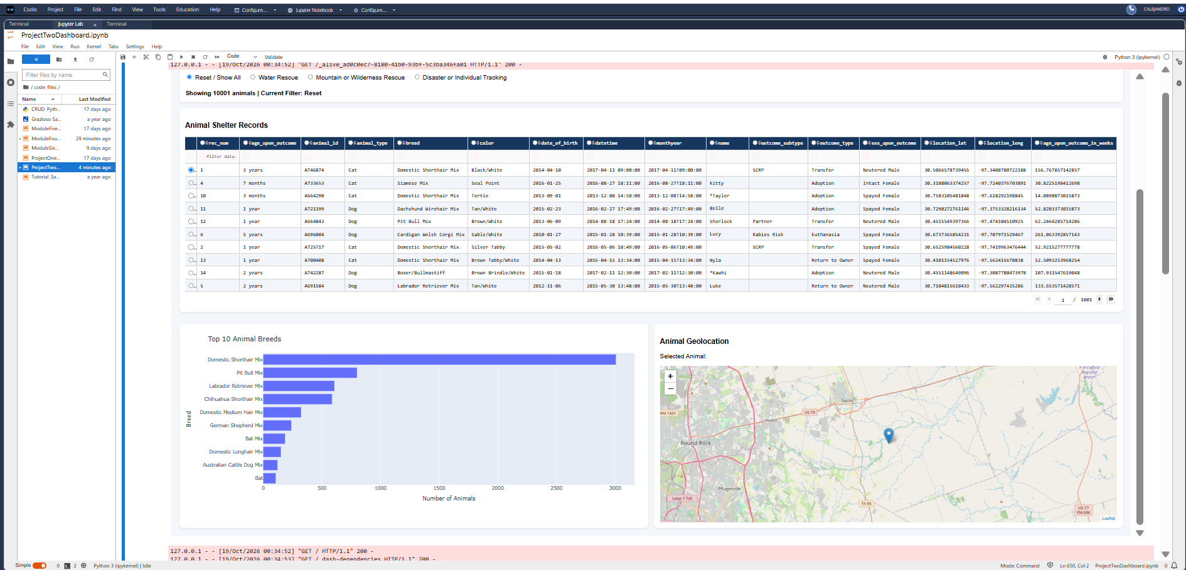

Dashboard Screenshot Evidence
Figure 2. Water Rescue — 17 matching records with chart and geolocation map.
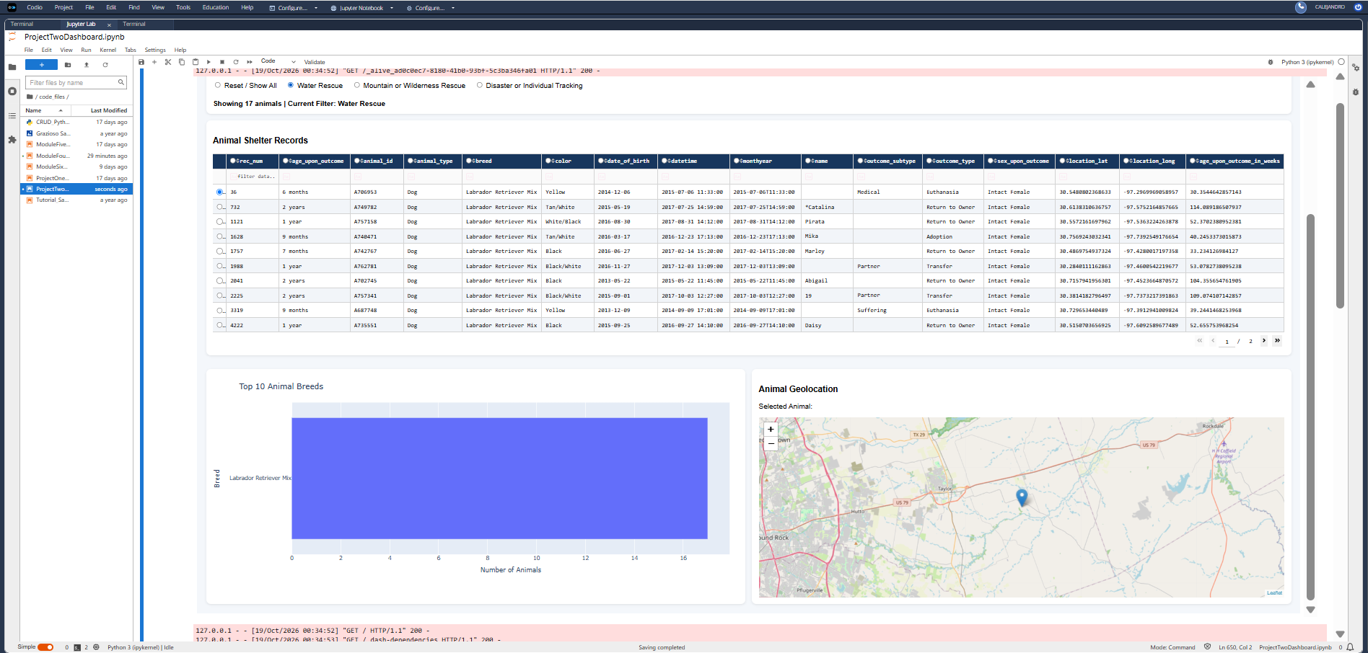

Dashboard Screenshot Evidence
Figure 3. Mountain or Wilderness Rescue — 5 matching records with chart and map.
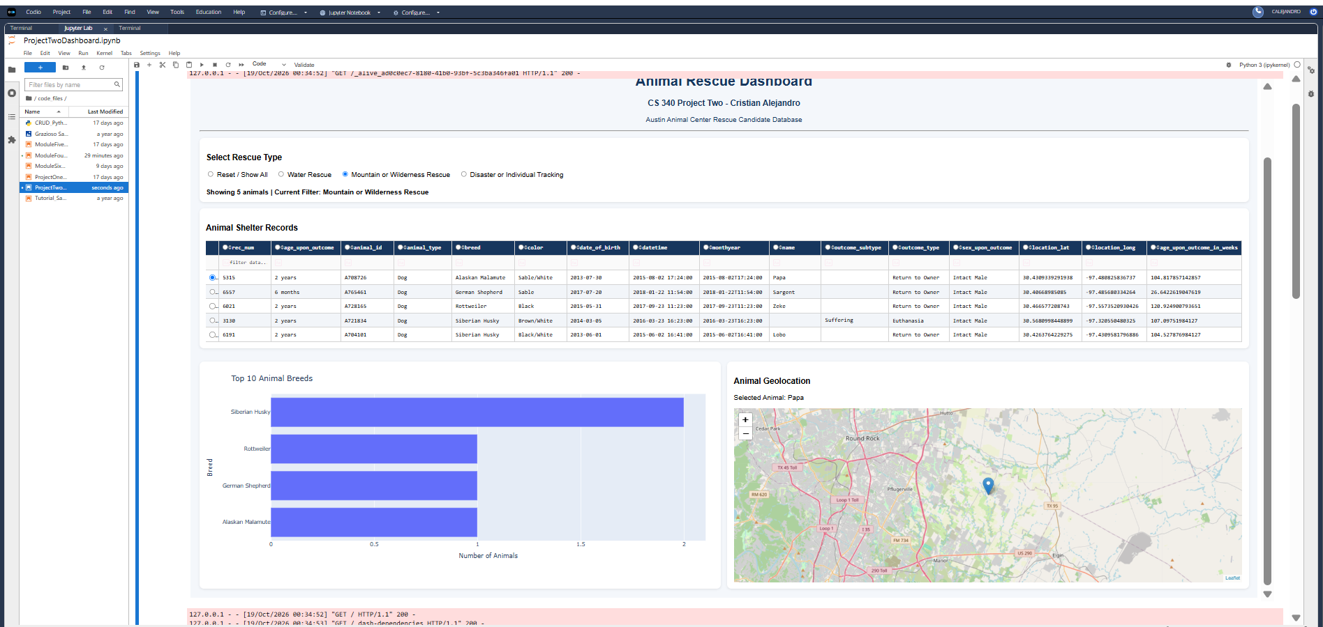

Dashboard Screenshot Evidence
Figure 4. Disaster or Individual Tracking — 4 matching records with chart and map.
